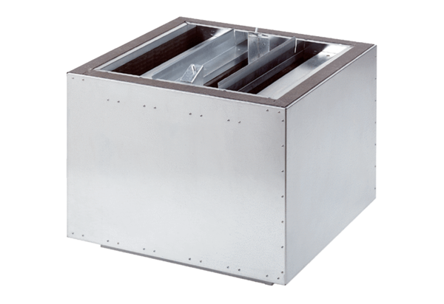Exhaust air silencer SDA 22Packing unit: 1 pieceRange: C
Article number: 0092.0386Manufacturer: MAICO

