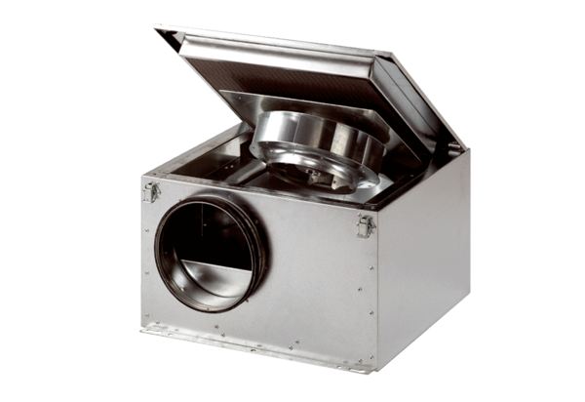Sound-insulated ventilation box ESR 12 SPacking unit: 1 pieceRange: C
Article number: 0080.0227Manufacturer: MAICO

