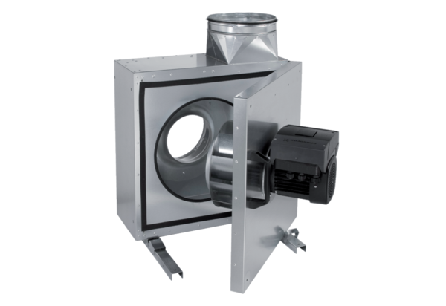Sound-insulated ventilation box EKR 31 FUPacking unit: 1 pieceRange: E
Article number: 0080.0896Manufacturer: MAICO

