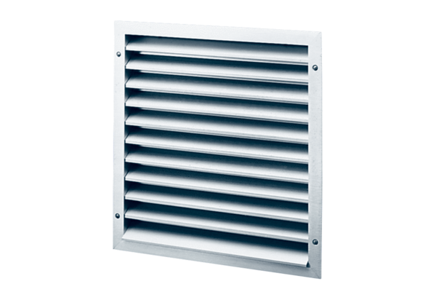External grille MLA 50Packing unit: 1 pieceRange: C
Article number: 0151.0116Manufacturer: MAICO

