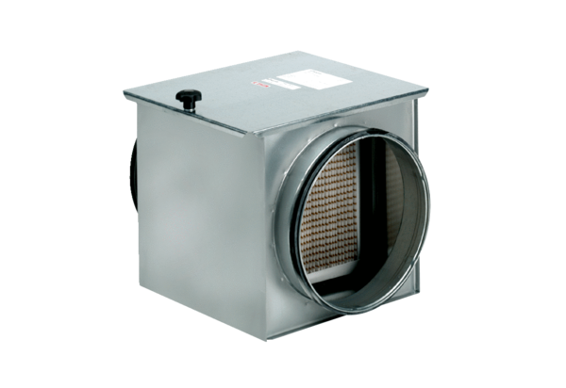Air filter TFE 16-5Packing unit: 1 pieceRange: C
Article number: 0149.0061Manufacturer: MAICO

