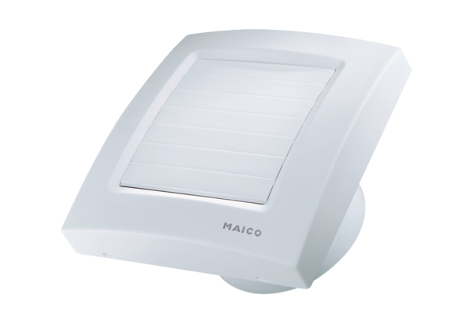Small room fan ECA 120 KFPacking unit: 1 pieceRange: A
Article number: 0084.0011Manufacturer: MAICO

