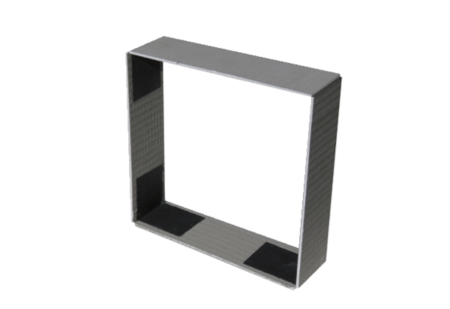Wall frame ER-MR ECPacking unit: 1 pieceRange: B
Article number: 0192.0765Manufacturer: MAICO

