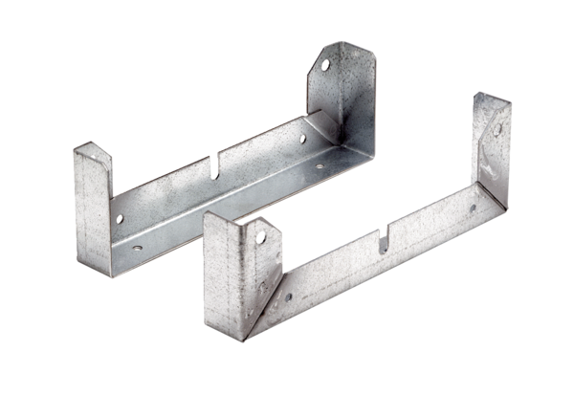Mounting foot FU 45Packing unit: 2 piecesRange: C
Article number: 0036.0074Manufacturer: MAICO

