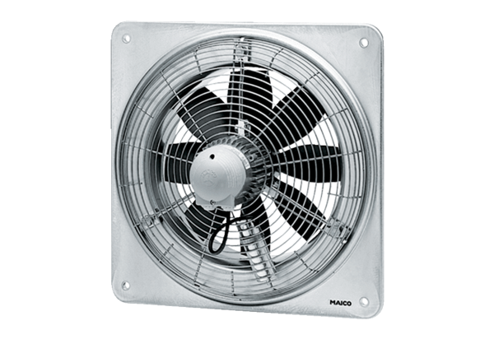Axial wall fan DZQ 30/6 BPacking unit: 1 pieceRange: C
Article number: 0083.0119Manufacturer: MAICO

