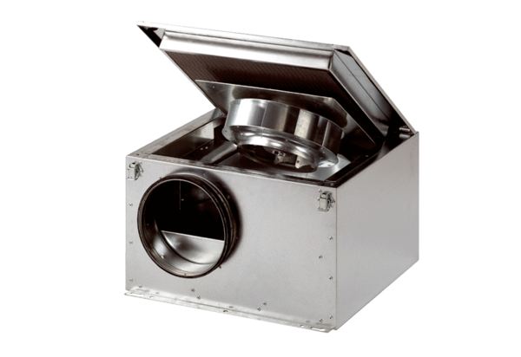Sound-insulated ventilation box ESR 31 SPacking unit: 1 pieceRange: C
Article number: 0080.0231Manufacturer: MAICO

