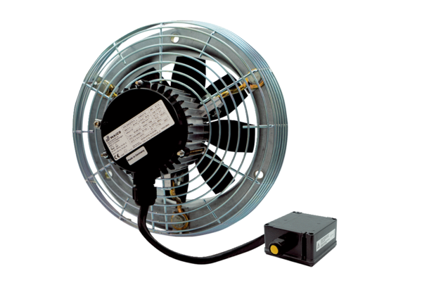Axial wall fan DZS 35/6 B Ex ePacking unit: 1 pieceRange: C
Article number: 0094.0123Manufacturer: MAICO

