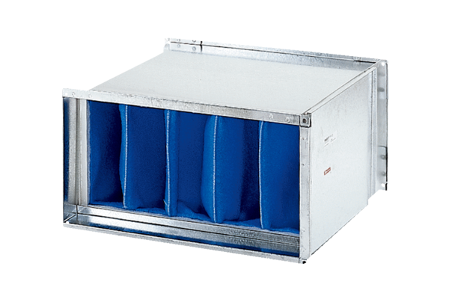Air filter TFP 28-7Packing unit: 1 pieceRange: D
Article number: 0149.0069Manufacturer: MAICO

