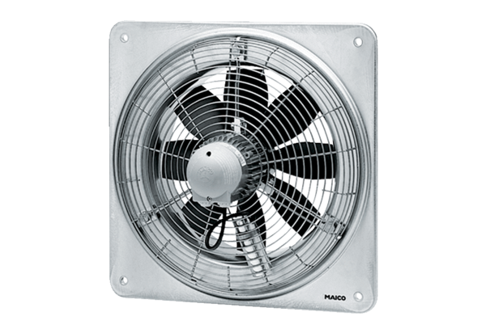Axial wall fan DZQ 35/42 BPacking unit: 1 pieceRange: C
Article number: 0083.0066Manufacturer: MAICO

