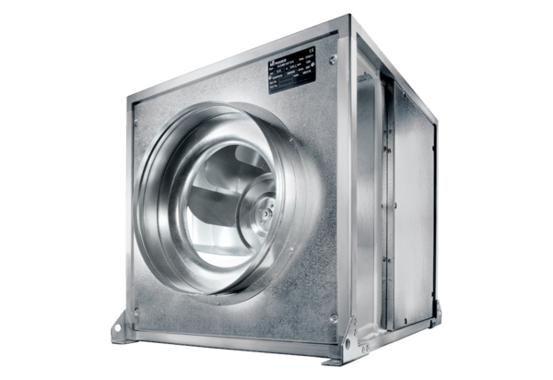Quickbox DSQ 50/6 KPacking unit: 1 pieceRange: C
Article number: 0080.0081Manufacturer: MAICO

