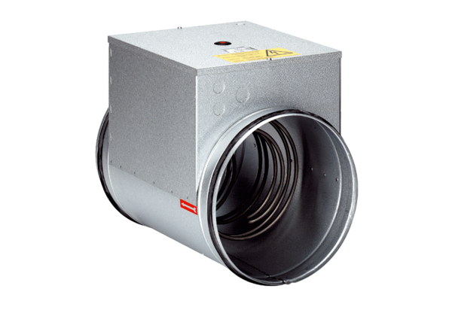Electrical air heater DRH 20-5Packing unit: 1 pieceRange: C
Article number: 0082.0106Manufacturer: MAICO

