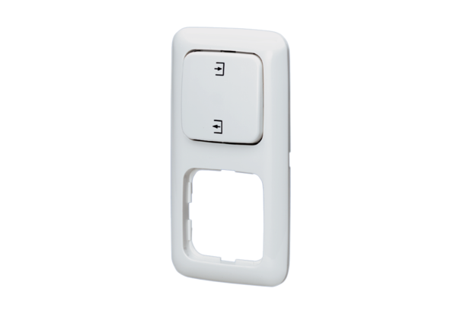Reversing switch UWK 1Packing unit: 1 pieceRange: C
Article number: 0157.0817Manufacturer: MAICO

