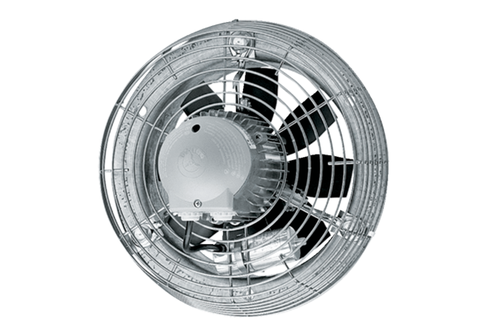Axial wall fan DZS 30/84 BPacking unit: 1 pieceRange: C
Article number: 0094.0042Manufacturer: MAICO

