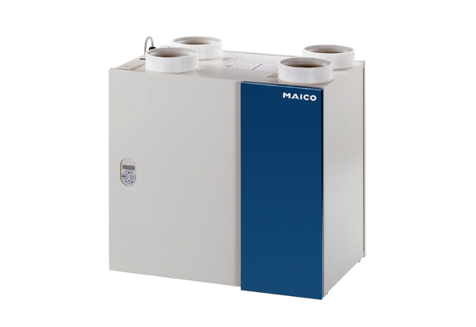Centralised ventilation unit WRG 180 ECPacking unit: 1 pieceRange: K
Article number: 0082.0059Manufacturer: MAICO

