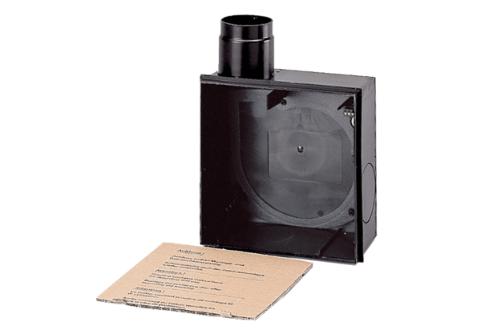Recessed-mounted housing ER - UP/GPacking unit: 1 pieceRange: B
Article number: 0093.0995Manufacturer: MAICO

