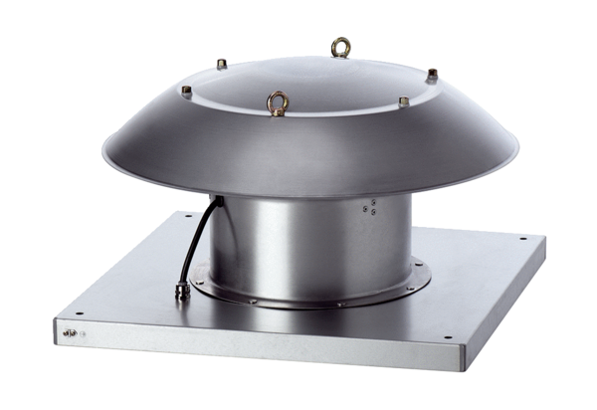Axial roof fan DZD 25/2 B Ex ePacking unit: 1 pieceRange: C
Article number: 0087.0797Manufacturer: MAICO

