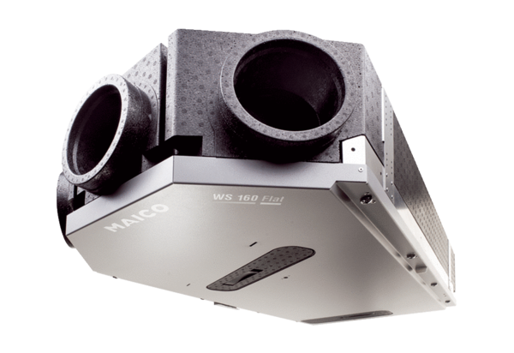Centralised ventilation unit WS 160 Flat ETPacking unit: 1 pieceRange: K
Article number: 0095.0090Manufacturer: MAICO

