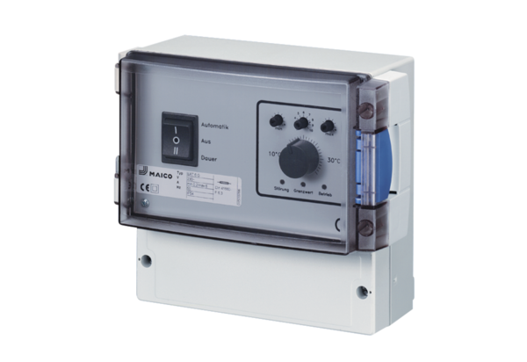Temperature control system EAT 6 G/1Packing unit: 1 pieceRange: C
Article number: 0157.0808Manufacturer: MAICO

