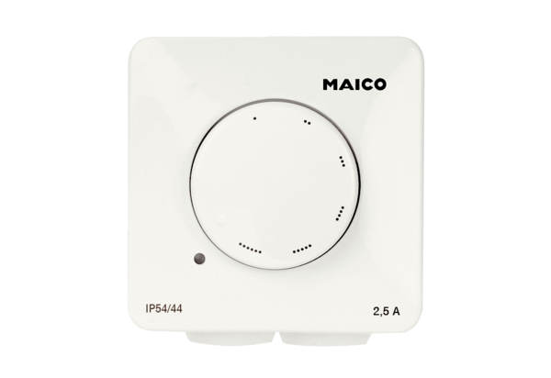Speed controller STX 4Packing unit: 1 pieceRange: C
Article number: 0157.1563Manufacturer: MAICO

