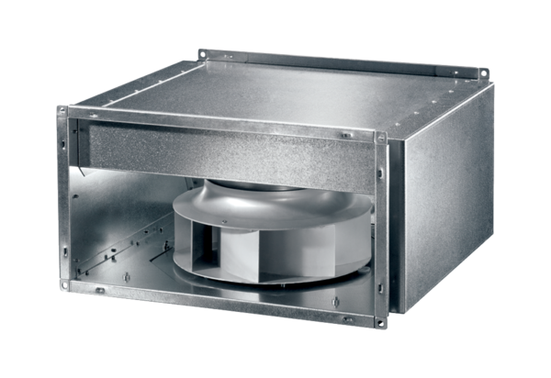Sound-insulated channel fan DSK 22 ECPacking unit: 1 pieceRange: E
Article number: 0086.0801Manufacturer: MAICO

