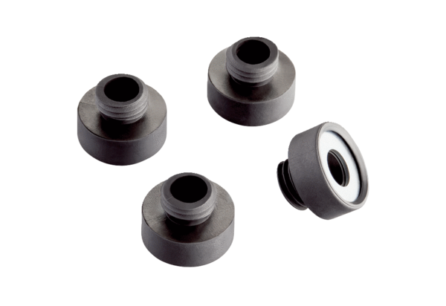Sound insulation set KSD-DPacking unit: 4 piecesRange: C
Article number: 0092.0521Manufacturer: MAICO

