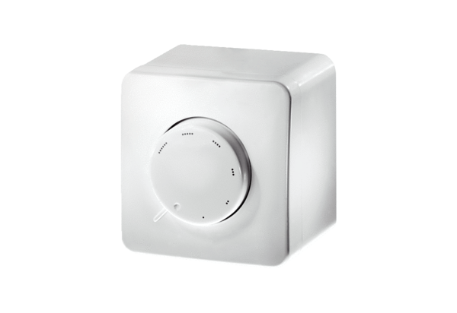Potentiometer ST EC 230Packing unit: 1 pieceRange: E
Article number: 0157.0109Manufacturer: MAICO

