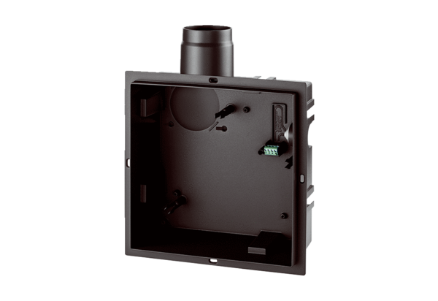Recessed-mounted housing ER GHPacking unit: 1 pieceRange: B
Article number: 0084.0350Manufacturer: MAICO

