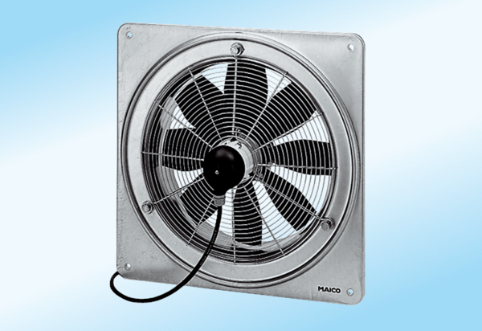Axial wall fan DZQ 35/4 A-ExPacking unit: 1 pieceRange: C
Article number: 0083.0771Manufacturer: MAICO

