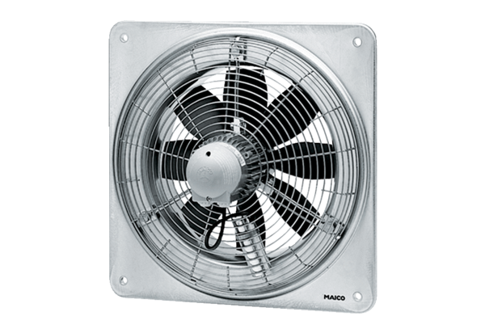Axial wall fan EZQ 45/6 BPacking unit: 1 pieceRange: C
Article number: 0083.0100Manufacturer: MAICO

