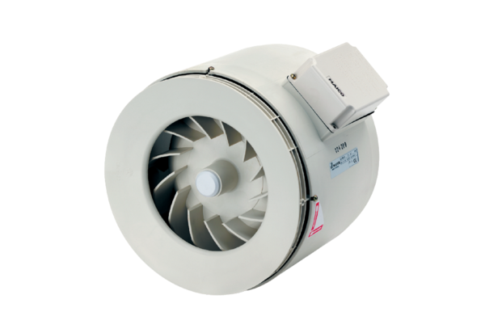Semi-centrifugal duct fan ERM 22Packing unit: 1 pieceRange: C
Article number: 0080.0204Manufacturer: MAICO

