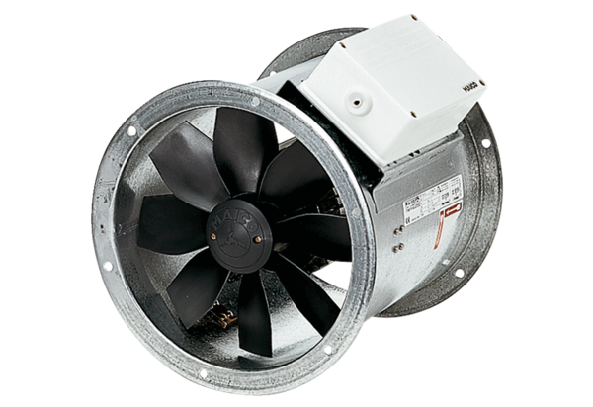Axial duct fan DZR 30/4 BPacking unit: 1 pieceRange: C
Article number: 0086.0024Manufacturer: MAICO

