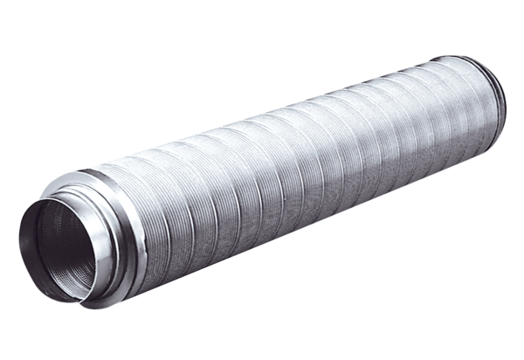Tubular sound absorber RSR 28Packing unit: 1 pieceRange: C
Article number: 0092.0318Manufacturer: MAICO

