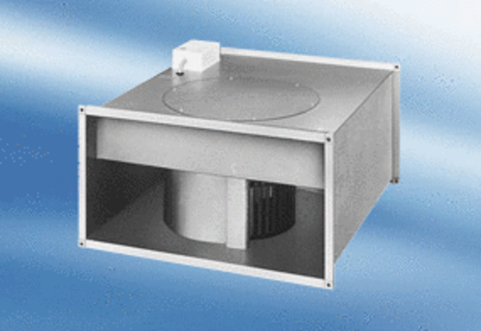Channel fan DPK 35/6 APacking unit: 1 pieceRange:
Article number: 0086.0638Manufacturer: MAICO

