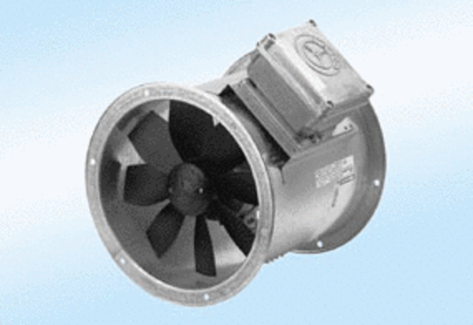Axial duct fan DZR 40/6 A-ExPacking unit: 1 pieceRange: C
Article number: 0086.0775Manufacturer: MAICO

