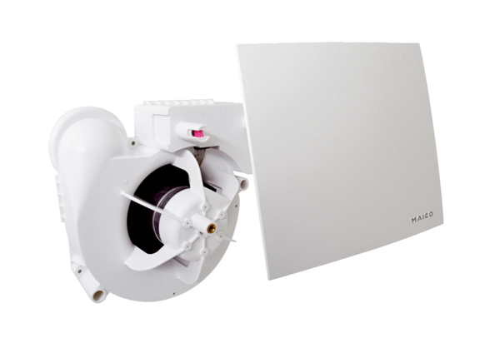Fan insert ER 60 EVZPacking unit: 1 pieceRange:
Article number: 0084.0372Manufacturer: MAICO

