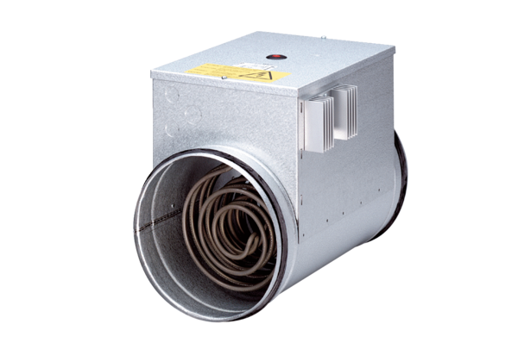Electrical air heater with controller DRH 25-9 RPacking unit: 1 pieceRange: C
Article number: 0082.0145Manufacturer: MAICO

