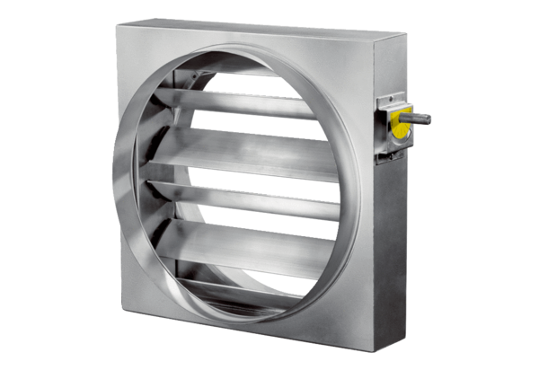Control shutter JRE 35Packing unit: 1 pieceRange: C
Article number: 0151.0392Manufacturer: MAICO

