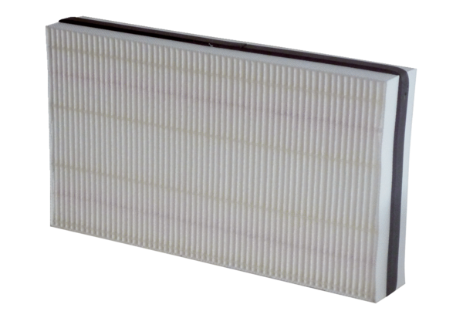Air filter, replacement WSF 170Packing unit: 1 pieceRange: K
Article number: 0093.0271Manufacturer: MAICO

