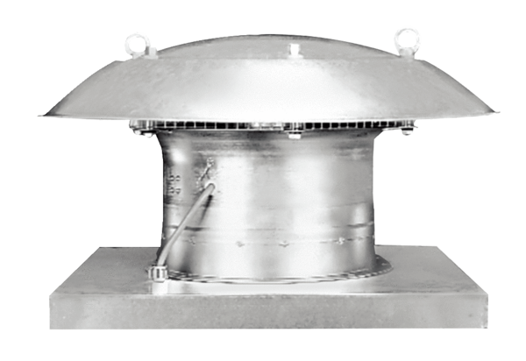Axial roof fan EZD 30/4 BPacking unit: 1 pieceRange: C
Article number: 0087.0204Manufacturer: MAICO

