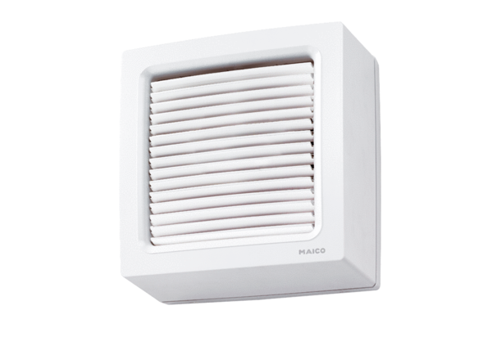Axial window fan EVN 22Packing unit: 1 pieceRange: C
Article number: 0080.0855Manufacturer: MAICO

