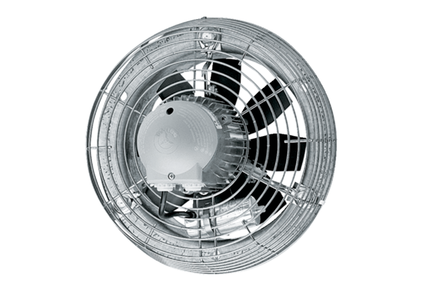Axial wall fan EZS 35/6 BPacking unit: 1 pieceRange: C
Article number: 0094.0005Manufacturer: MAICO

