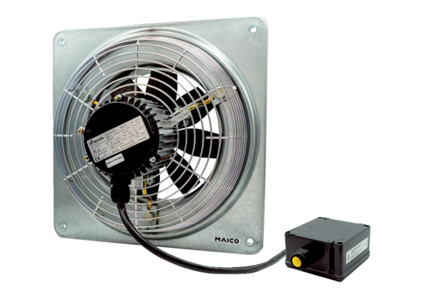Axial wall fan DZQ 50/6 B Ex ePacking unit: 1 pieceRange: C
Article number: 0083.0184Manufacturer: MAICO

