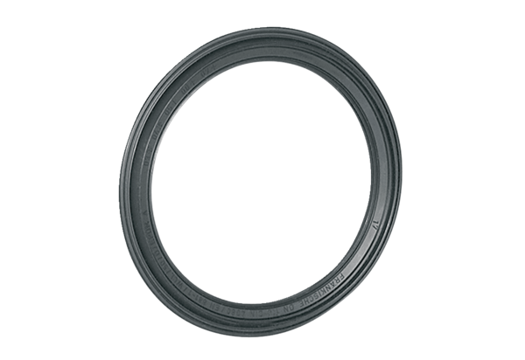Sealing ring MF-FDR75Packing unit: 10 piecesRange: K
Article number: 0175.0262Manufacturer: MAICO

