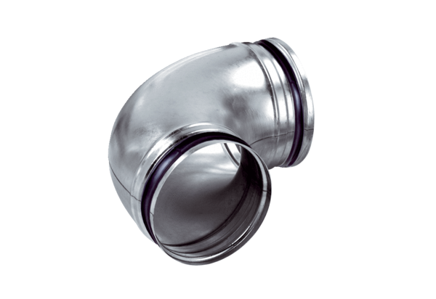90° elbow, drawn B90-125Packing unit: 1 pieceRange: K
Article number: 0055.0312Manufacturer: MAICO

