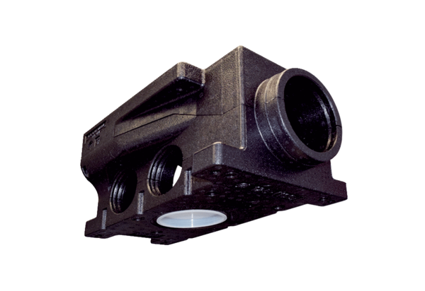Compact air distributor made of plastic, 7-way MF-VK90-7Packing unit: 1 pieceRange: K
Article number: 0059.0994Manufacturer: MAICO

