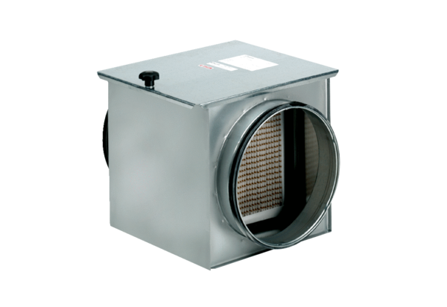Air filter TFE 40-7Packing unit: 1 pieceRange: C
Article number: 0149.0057Manufacturer: MAICO

