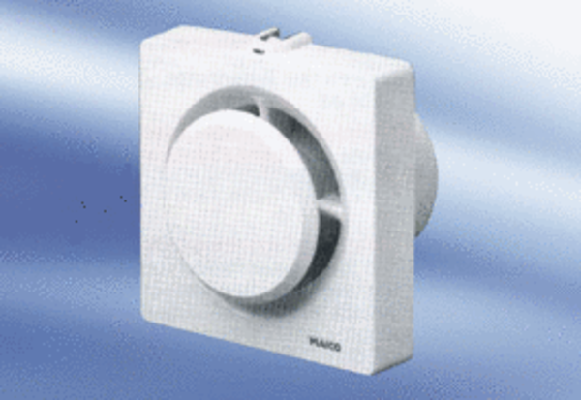Small room fan ECA 11-1 KVZPacking unit: 1 pieceRange:
Article number: 0080.0506Manufacturer: MAICO

