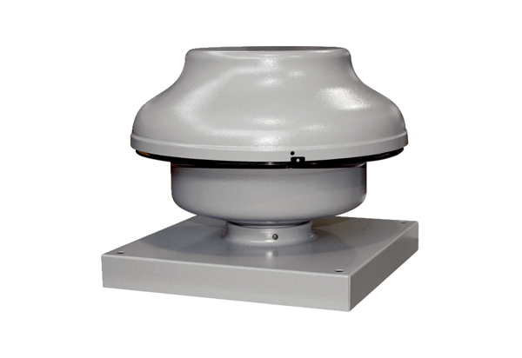Centrifugal roof fan EHD 31Packing unit: 1 pieceRange: C
Article number: 0087.0306Manufacturer: MAICO

