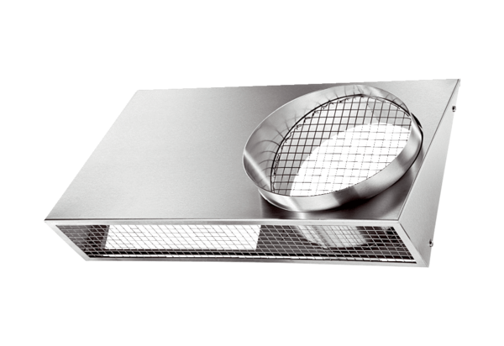Combi-wall connections KWH 12 LPacking unit: 1 pieceRange: K
Article number: 0152.0059Manufacturer: MAICO

