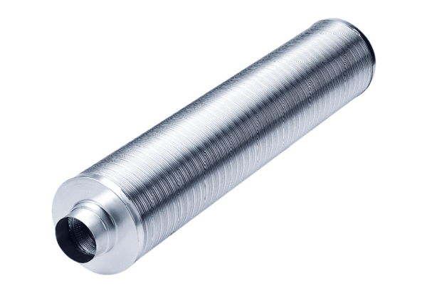Tubular sound absorber RSR 20/50Packing unit: 1 pieceRange: C
Article number: 0092.0326Manufacturer: MAICO

